CREDITI CARD EXPENDITURE FORECASTING

Objective: - Enhance marketing efforts to boost average credit card spending effectively.

Business Problem: -
- The primary objective is to boost credit card spending among potential clients. This insight enables banks to tailor services and develop effective strategic marketing plans.
Data availability: -
- Customer Demographics data ( Customer details like age , gender , employment experience etc)
- Customer Behaviour data ( Customer consumption expenditure data of 3months )
- Customer Consumption ( Customer id and consumption data)

Tools used :- python (Pandas , NumPy, MatPlot, Seaborn ,Sklearn )
Techniques :-
- Exploratory Data Analysis & Data Transformation
- The objective of this phase was to clean the raw data and prepare the feature set for the machine learning pipeline. The process involved auditing 20,000 records across 28 features to ensure data integrity and statistical validity.
- Data Integration and Auditing

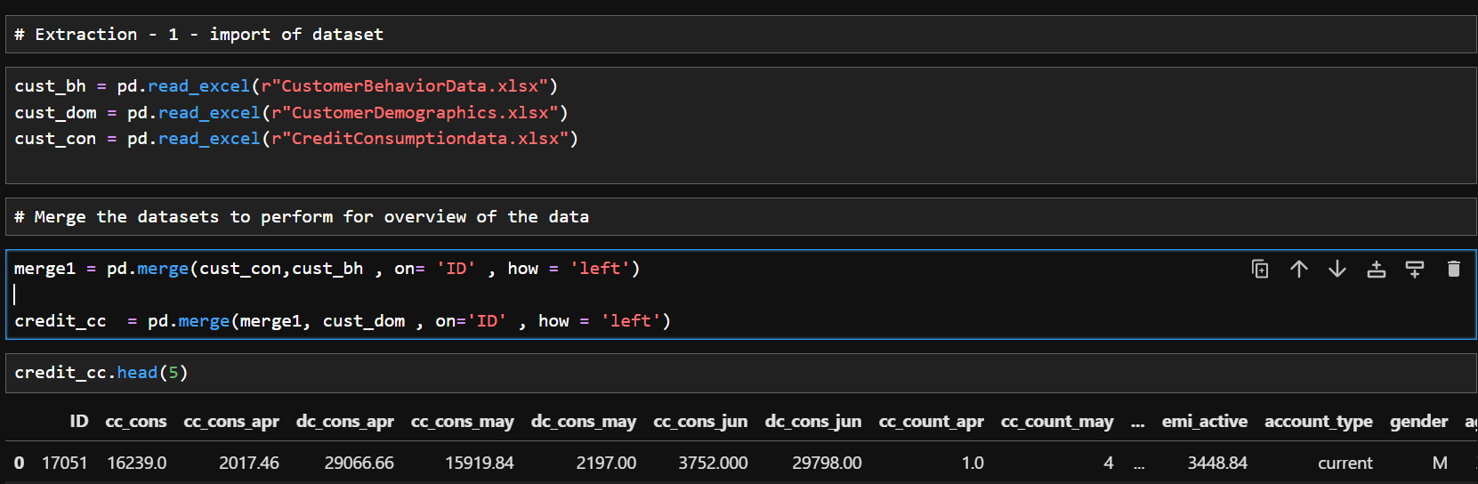
- Dataset Merging: Data was successfully integrated from three sources (cust_con, cust_bh, and cust_dom) using a left join on the unique Customer ID.

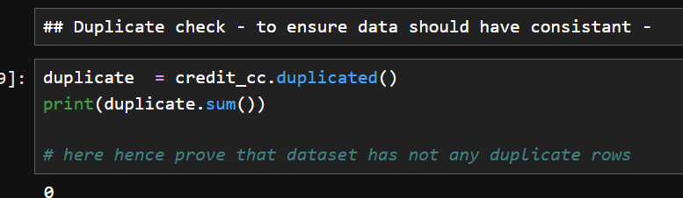
- Duplicate Check: A thorough audit confirmed 0 duplicate rows, ensuring each Customer entry represents a unique financial profile.

- Missing Value Management: * The target variable (cc_cons) contained 5,000 missing values, which were separated to form the final prediction (missing) set.
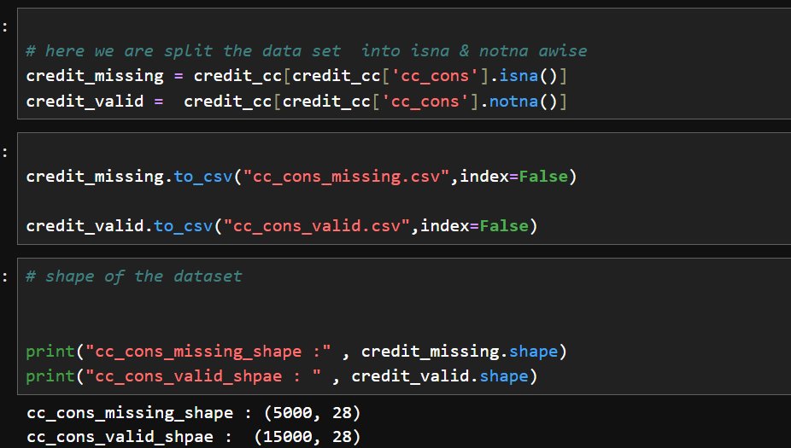

- Minor missingness (1-2 records) in columns such as emi_active and investment_3 were addressed via imputation to maintain a complete feature matrix.
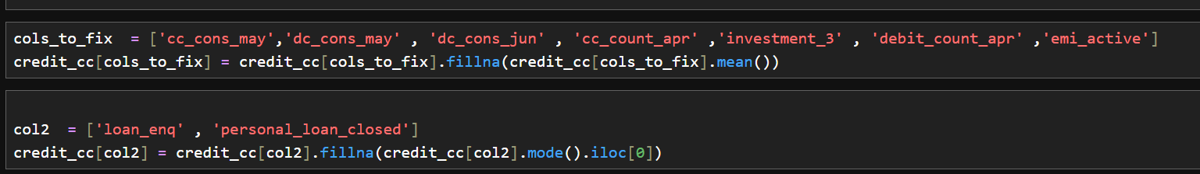

- Statistical Profiling
- Initial descriptive statistics revealed significant challenges that guided the transformation strategy:
- Skewness: The average spend was ~9,369, but the maximum reached 160,735, indicating a high degree of right-skewness.
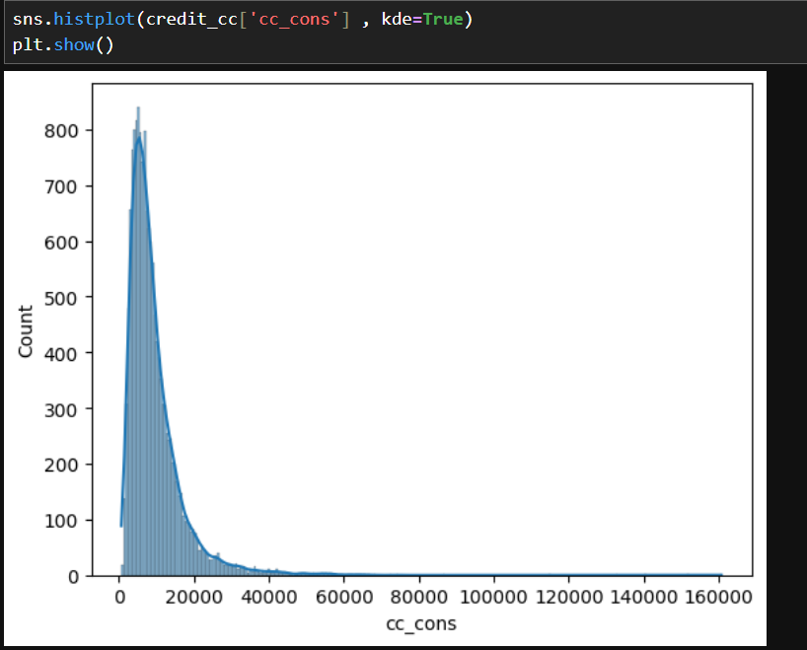

- Variance: Features like total_spend_credit_cc showed a standard deviation of 41,341, suggesting that a standard linear approach would be sensitive to extreme variances.
- Feature Transformation (The "Pipeline")
- To stabilize the model, the following transformations were applied:

- Winsorization: We identified that the top 1% of spenders created statistical "noise." Data was capped at the 99th percentile (40,000) to ensure the model focuses on the core Customer population.
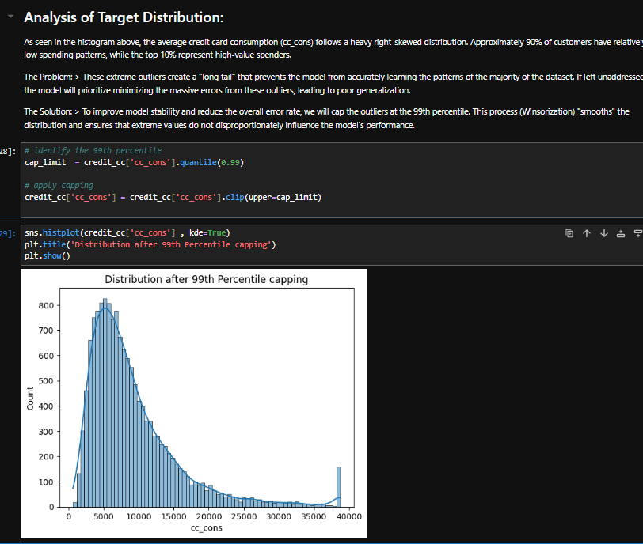

Key performance Indicator

- Credit Utilization ratio

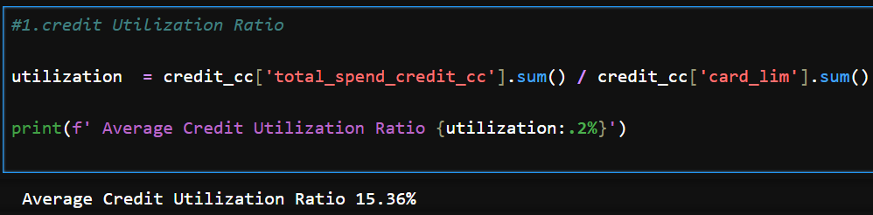
Answer:- Credit Utilization ratio – this ratio if more than >70 may indicate financial stress, while low utilization suggests an opportunity to encourage more spending , - here on average the it indicate that below >70% it suggest to encourage for more spending.
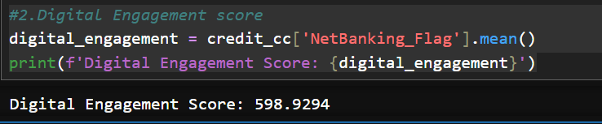
- Digital Engagement score represent the customer engagement in digital transaction - out of 100% , customer engagement rough 60% that mean customer digital transaction here increase and we have do more marketing campaign on the digital transaction – to increase customer engagement more frequently – try to more offer like – trans points and vouchers to increase the percentage

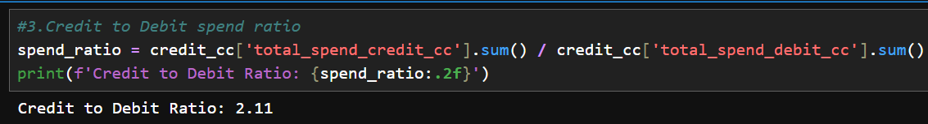

Credit to Debit spend ratio here is 2.11 on an average customer credit card is most used for in there day to day transaction, its assumption maybe they us it for rewards and cash back and also its profitable for landing bank ,

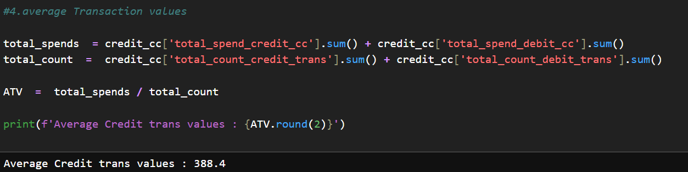
• Mass Market Positioning: This is a classic "mass market" number. It’s too high for just small coffee/snack purchases, but too low for high-end luxury goods. It suggests regular utility, grocery, and dining spending.
• Business Opportunity: If the bank wants to increase revenue, they now know the target. Moving this from 388 to 450 through "Buy One Get One" offers or high-value merchant discounts would significantly boost total volume.

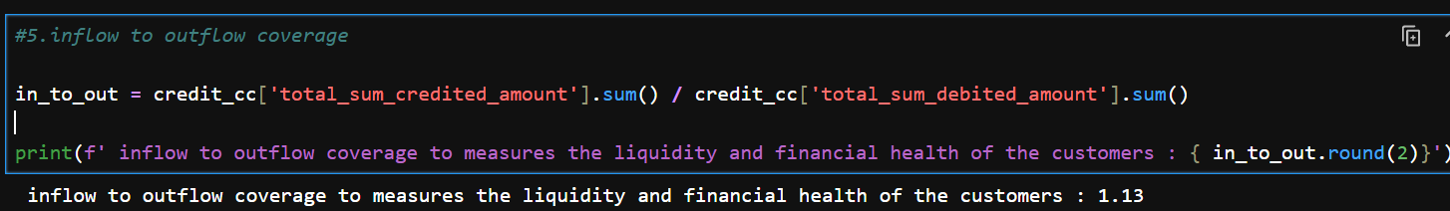

The ratio of inflow to outflow is 1.13 - customer more like of saving money rather than spend , its solid sign of bank liquidity ,its also show financial stability , low risk for bank and great opportunity - increase credit limit to customer those consume - points its average to for every customer
--------------------------------------------------------------------------------------------------------------------------------------

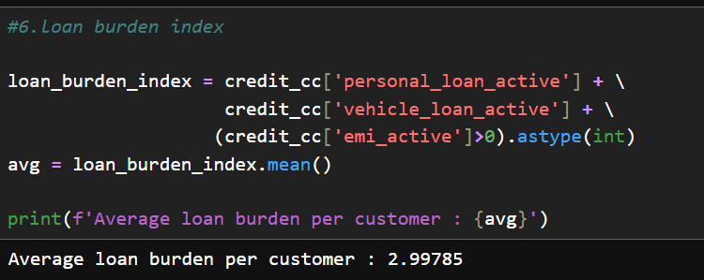
This loan burden index present that weather to enough to handle or take new loan or not – it already state that index score is approx. 3 its risk , but its avg customer have approx. 3 persent -its sign high right , before providing new loan it should take matter of consent.

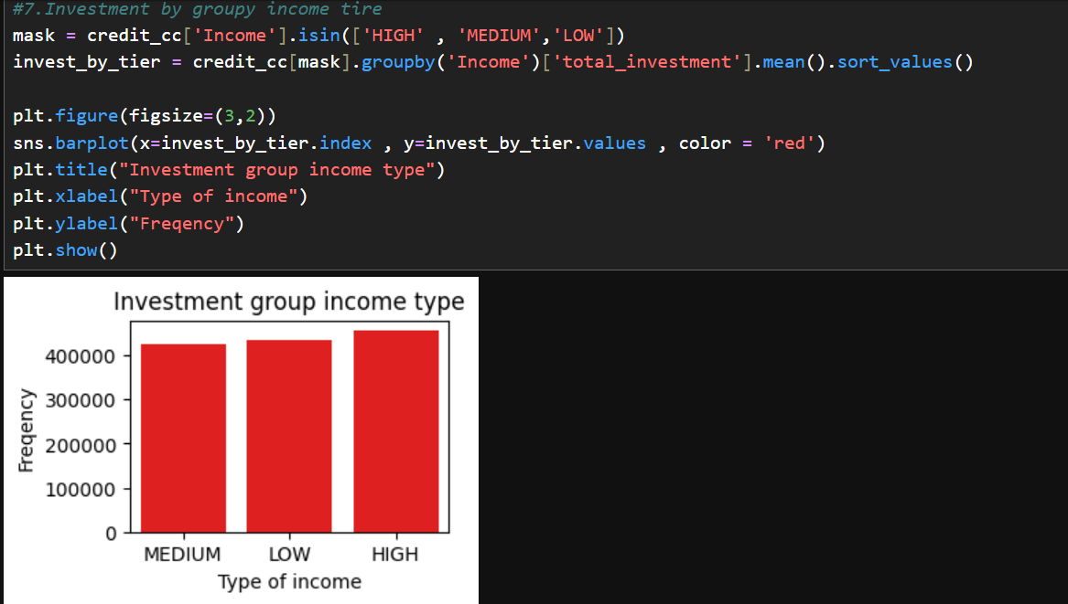
Here is Investment by grouped by income type we can see that on average every income type person overall investment go up to + 4lakhs

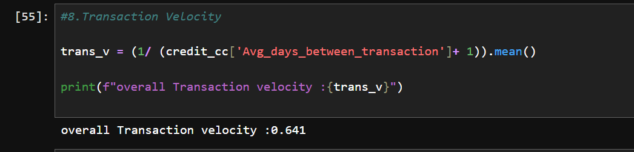
Here the Transaction Velocity is between the 0 to 1 , its moderate score - customer using card general and frequently and to pay bills. Its actively use of score in moderate way

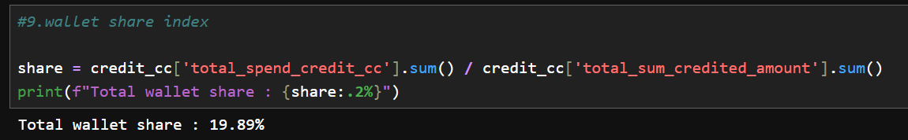

Wallet share index was 19.98 % that means customer uses the credit card for specific purpose only , non – exlusive , to increase heavy marketing campaign to increase the wallet share

- Logarithmic Scaling: Given that financial data often follows a power-law distribution, we applied a Log Transformation to the target variable. This transformed the skewed spend distribution into a Gaussian-like (normal) curve, allowing the Gradient Boosting algorithm to converge more effectively.

- Categorical Encoding: Non-numeric features like Income, gender, and Account type were transformed into numeric formats using a pre-processing pipeline, making them readable for the mathematical models.
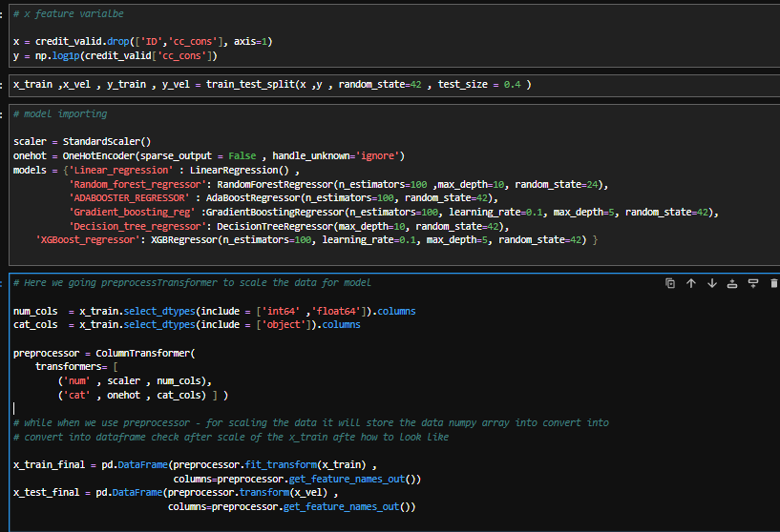

- Model Development and Evaluation

- This phase involved the comparative analysis of multiple regression algorithms, fine-tuning for optimal performance, and a final validation through visual and statistical metrics.
- Model Prediction & Evaluation Trackers
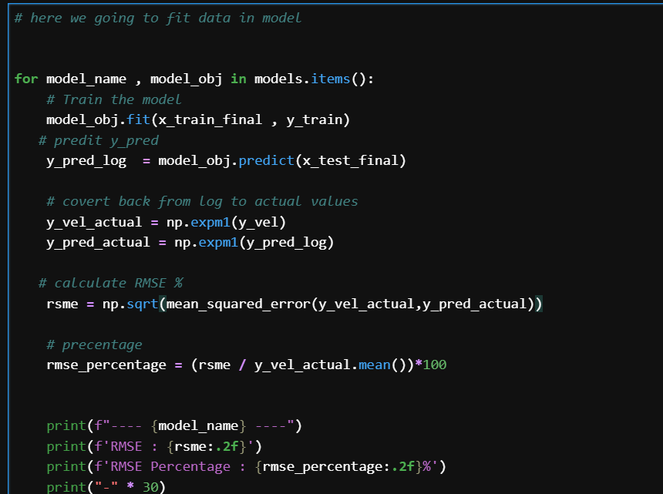
- We implemented a standardized evaluation framework to test six different algorithms. To ensure comparability, we tracked two primary metrics: Root Mean Squared Error (RMSE) and RMSE Percentage.

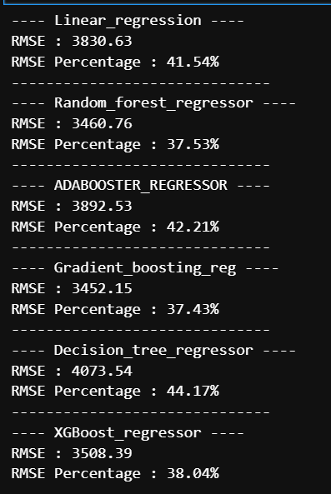
- Base Models Tested: Linear Regression, Random Forest, AdaBoost, Gradient Boosting, Decision Trees, and Boost.

- Metric Logic: Because the target variable was log-transformed, we performed an inverse transformation ($expm1$) before calculating the error to ensure the RMSE reflects actual currency values.
- Initial Results: Gradient Boosting emerged as the strongest candidate with an initial
- RMSE Percentage of 37.43%, closely followed by Random Forest.
- Hyperparameter Tuning (Grid Search)
- To maximize the potential of the Gradient Boosting Regressor, we performed an exhaustive GridSearchCV with 5-fold cross-validation.
- Parameters Optimized: learning_rate, n_estimators, max_depth, and subsample.
- The "Best Model": The search identified that a Lower Learning Rate (0.01) and higher Estimators (500) were required to prevent the model from overfitting to noise while capturing the underlying spending signals.
- Result: This optimization stabilized the model, bringing the final error rate to a robust 37.13%.
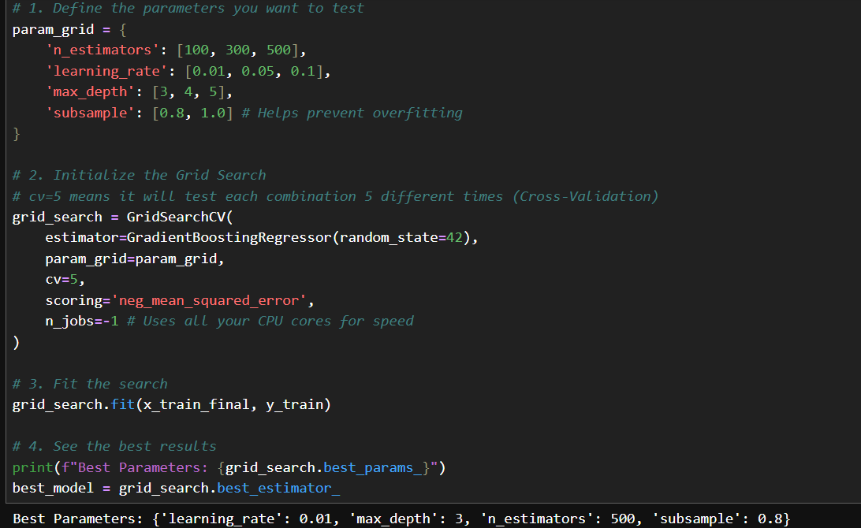
- Comparison: Actual vs. Predicted Charts
- A scatter plot analysis was conducted to visualize the relationship between the actual bank spend and the model’s forecasts.
- The Diagonal Test: A 45-degree reference line was used to measure bias.
- Findings: The model showed high accuracy in the 5,000 to 20,000 range (the core Customer base). While it exhibited a conservative bias for extreme high-spenders (near the 40,000 cap), the overall alignment confirmed that the model effectively captured the "Normal" spending behavior of the bank's population.

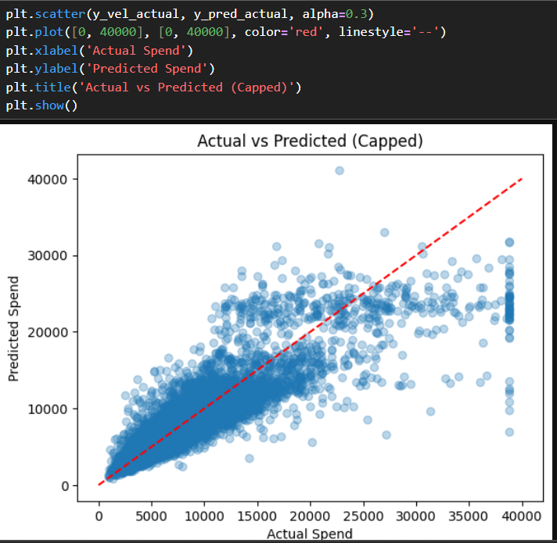
- Prediction on Missing Data
- The finalized model was deployed on the credit_missing dataset containing 5,000 records.
- Pipeline Alignment: The missing data was subjected to the exact same preprocessing and feature selection (Top 10 features) used during training.
- Outcome: The model generated a final consumption forecast for each Customer ID, which was then exported to Credit_Consumption_Predictions.csv for business use.
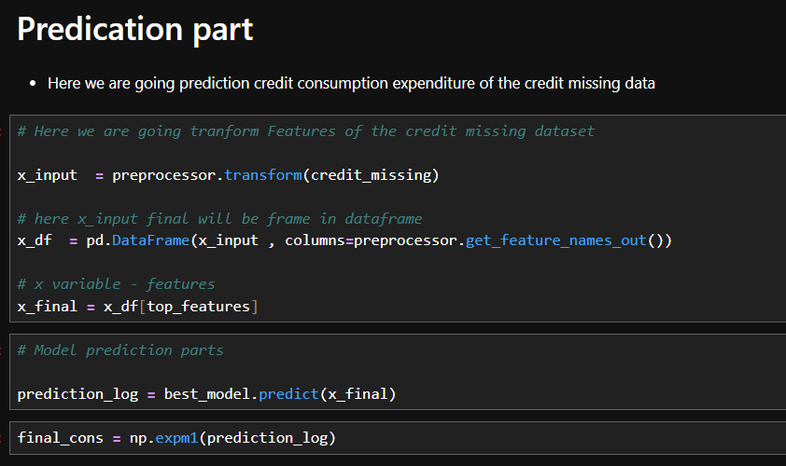
- Final Validation (Distribution Comparison)
- To ensure the model's "logic" was consistent, we compared the distribution of the predicted values against the historical training data.
- The Histogram Check: The overlap between the Predicted Spend and Actual Spend distributions confirmed that the model successfully mirrored real-world spending habits.
